ELECTRICAL FEEDER SHUTTLE COMMUNICATION CABLE

- PARTS:

QUANTITY: PART #: NOMENCLATURE: LENGTH:

1 PER CABLE (1 PER MACHINE) 19077- CABLE, 3-COND., SHIELDED, 22 AWG 64 INCHES

2 PER CABLE (2 PER MACHINE) 17585-2 HOUSING, 3-PIN MOLEX N/A

6 PER CABLE (6 PER MACHINE) 18729- TERMINAL, CRIMP, GOLDPLATE N/A

2 PER CABLE (2 PER MACHINE) 46160- TUBING, SHRINK, ¼” BLACK ½ INCH

- ASSEMBLY:

- STRIP 1 INCH OF OUTER INSULATION FROM EACH END OF THE CABLE.

- PLACE AND SHRINK A ½ INCH PIECE OF SHRINK TUBING OVER EACH TERMINATION POINT OF THE OUTER INSULATION.

- STRIP 1/8 INCH OF INSULATION FROM BOTH ENDS OF THE WIRES.

- CRIMP SIX GOLD-PLATED TERMINALS TO THE STRIPPED WIRE ENDS AND TIN THEM, ACCORDING TO DIAGRAM 1.

- INSERT THE CRIMPED WIRES INTO THE 3-PIN HOUSINGS ACCORDING TO DIAGRAM 2.

NOTE 1
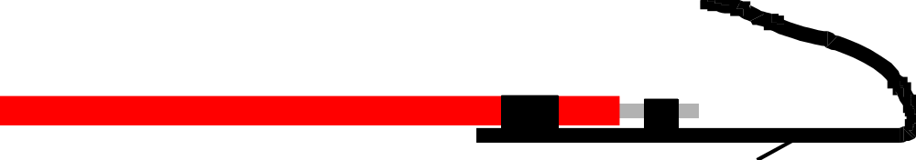IT IS CRITICAL THAT THE CRIMPED WIRES ARE INSERTED INTO THE HOUSINGS IN THE ORDER OF COLOR SPECIFIED. ANY VARIATION WILL CAUSE COMMUNICATION FAILURE, AND MAY CAUSE DAMAGE TO CIRCUITRY.

DIAGRAM 1



DIAGRAM 2

